NEELAM RAWAT

Assisstant proffessor

Education Department

NIMBUS SCHOOL OF EDUCATION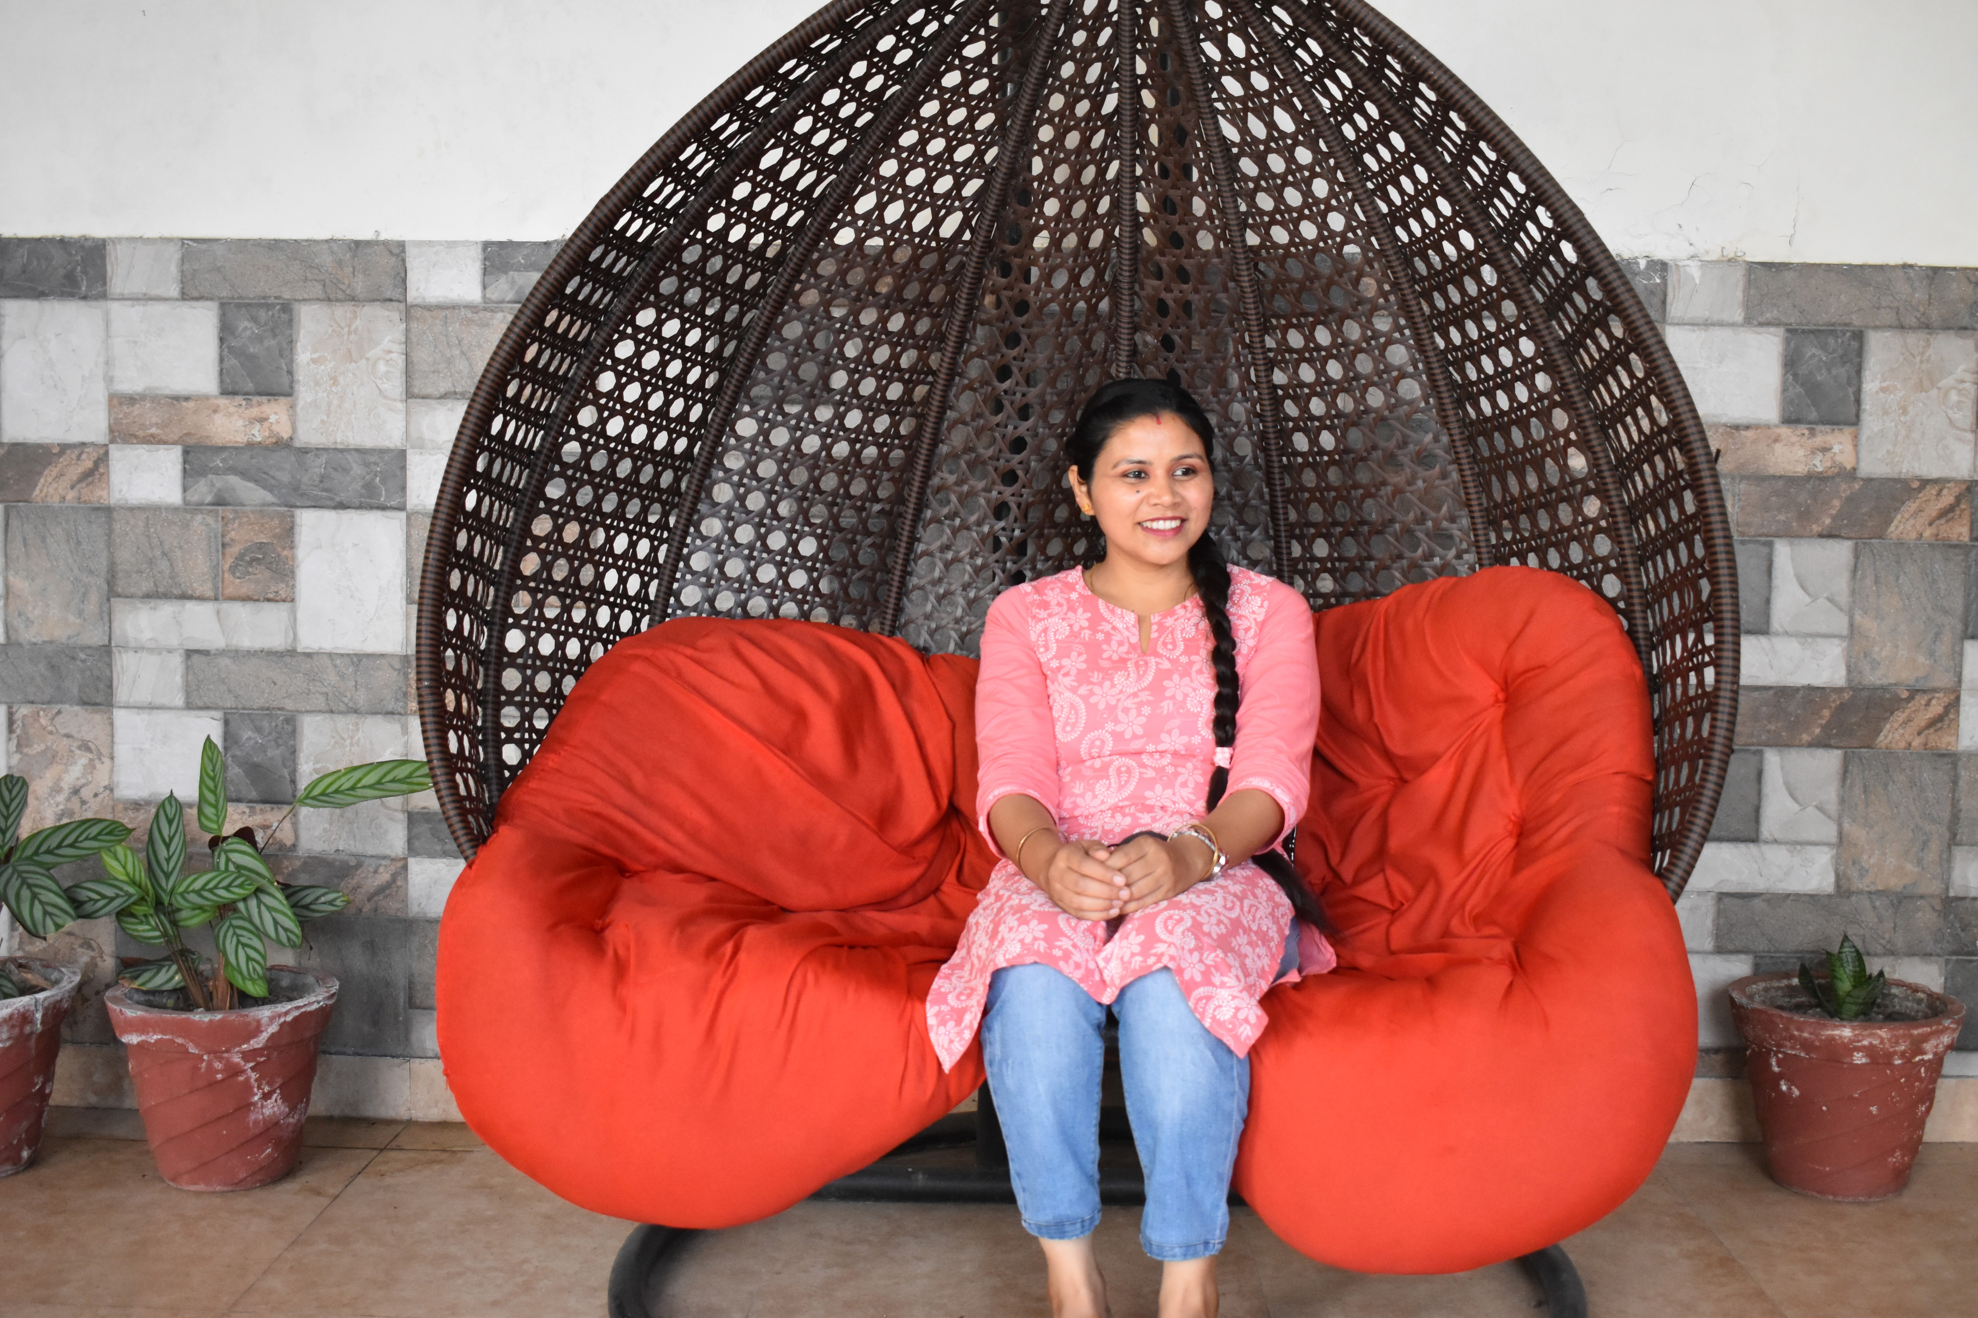

Area

Teaching and learning

**Education**

Pursuing Ph.D in Education

M.A. Economics from Maharaja Agrasen Himalayan Garhwal University (2022)

M.Ed from H.N.B.G.U Bidla Campus (2017).

M.Com from S.D.S.U.V (2017)

B.Ed from H.N.B.G.U (2015),( CTET QUALIFIED)

B.Com from H.N.B.G.U (2014)

**Teaching**

Childhood and growing up

Teaching and learning

**Research area**

**Guidance and counselling**

**Remote teaching and learning**

**Intellectual wellbeing**

**NEP 2020**

**Academic Experience**

**4 year teaching experience in B.Ed. College as an assistant professor.**

**2 year teaching experience as a PGT**

**Selected publications**

**Rawat, Neelam. (2024). Intellectual wellbeing. In Nitin Bajpai & Abhishek Sengar (Eds), Education for Wellbeing. (pp. 50-57). Blueroseone.**

Research paper published in IJARESM with topic “A Comparative Study on the Parents Opinion on Remote Learning of Their Wards Studying in Government and Non-Government Secondary Schools during COVID-19 Lockdown.”

Research paper published in Journal of Positive School Psychology with topic “A study on the Effect of COVID-19 towards the perception of Government Inter College Teachers in Dehradun District.”

**Academic Conferences**

Presentation of a paper on a “National Seminar” with topic “A study on the need of Guidance & Counselling at the secondary level of students.”

Presentation of a paper on a “National Seminar” with topic “COVID-19 and school administration: the roles responsibilities and challenges.

Presentation of a paper on a “National Seminar” with topic “COVID -19 and education: its consequences and opportunities.